Project Report: Intelligent Student Attendance Automation
Members: Liew Jun Lei, Kenneth

1. Executive Summary
Managing student attendance across multiple subjects and classes is a high-volume administrative task. This project utilizes UiPath to automate the data lifecycle: from reading raw attendance logs to calculating percentages, generating personalized PDF warning letters, and sending automated email notifications to both students and lecturers.

2. Workflow Explanation
The system operates through three primary phases:
- Phase 1: Data Consolidation & Analysis (MainLogic.xaml)
  - The robot iterates through every Excel file in the Student_Attendance_Input folder.
  - It calculates an Attendance % for every student using a dynamic formula that counts "P" (Present) and "MC" (Medical Certificate) entries against the total number of lessons.
  - A master database is built, mapping every student to their respective lecturer using Lecturer_Class_Mapping.xlsx.
- Phase 2: Targeted Student Warnings (Low Attendance)
  - The robot applies a threshold filter (e.g., < 75%) to identify at-risk students.
  - Document Automation: For each flagged student, the robot copies a Word template (Student_Attendance_WordDoc.docx) and uses the WordReplaceText activity to personalize it with the student's name, ID, class, and average attendance.
  - Conversion: The personalized document is exported to a formal PDF for professional delivery.
  - Direct Communication: The robot sends an email to the student (dynamically addressed to [ID]@hotmail.com) with the PDF attached and an HTML body containing a summary table of their attendance record.

Email Content:
Dear Jeffrey Allen :
[With PDF Attached]
Admission number: L401411W

You have been marked as having an insufficient Average attendance among your absent subjects of 64.29, less than 75%.

Here is your Attendance breakdown for your absent subjects:

Subject | Attendance %
Full Stack Development | 64.29
Internet of Things Project | 64.29

You will be subject to the respective institutional punishment.

By School Admins
Example PDF:
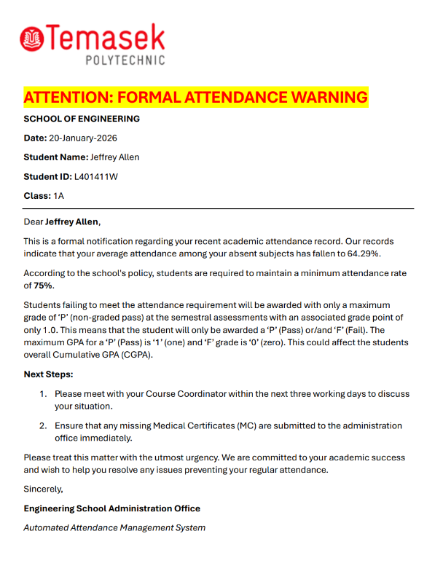
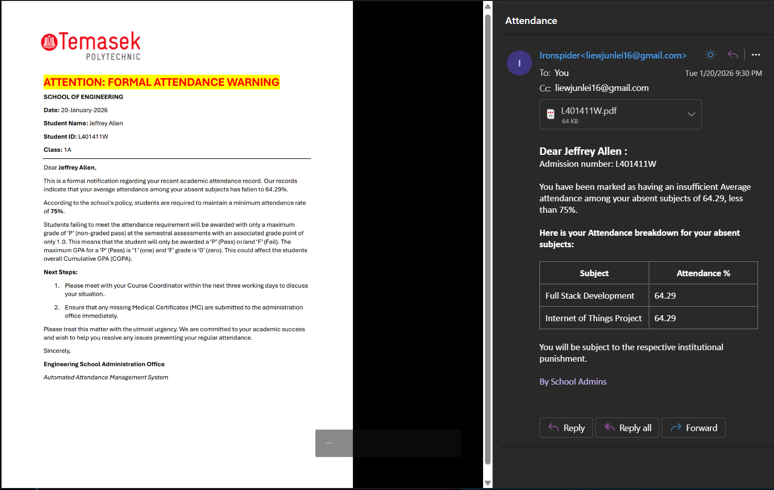

- Phase 3: Staff Reporting (Send_SummaryEmails_ToLecturers.xaml)
  - The robot filters the master data by lecturer and generates custom Excel summaries.
  - Reports are emailed to lecturers via Gmail integration, providing them with a holistic view of their students' performance.
  - Individual Classes and subjects pairs that the lecturer teaches will be sent in one excel file, separated by sheets, and Students at risk will be highlighted in yellow.
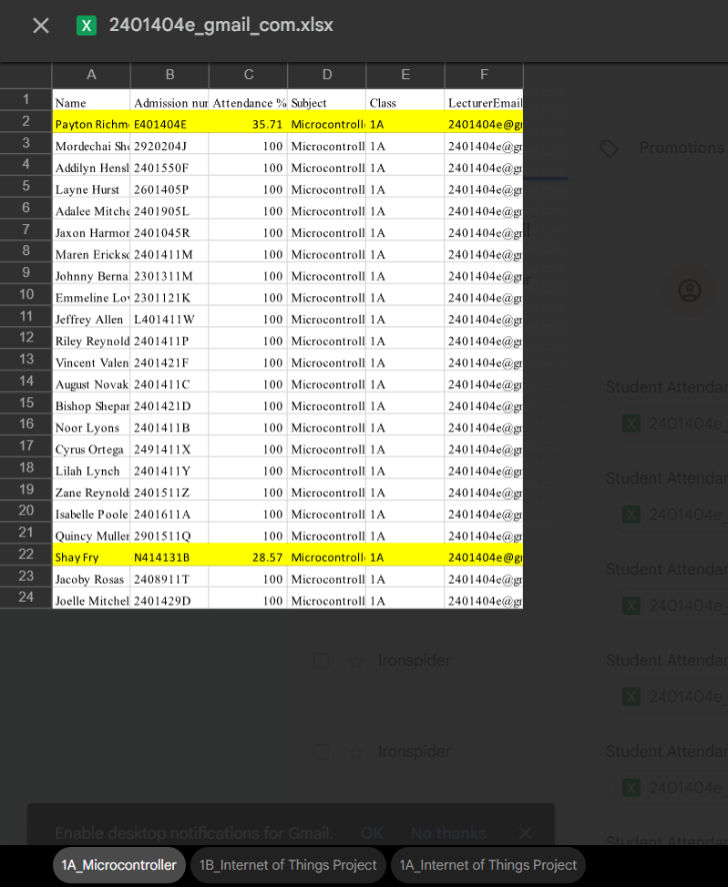

3. Assessment of Business Impact
a. Time Saved
- Manual Process: An administrator would spend approximately 15 minutes per student to verify data across multiple spreadsheets, draft a warning letter, convert it to PDF, and send an email. For 100 students, this is 25 hours of work.
- RPA Impact: The robot performs these tasks in roughly 10–15 seconds per student. The total processing time for 100 students is reduced to around 20~25 min, achieving a 98% reduction in time spent for humans.
b. Error Reduction
- Manual Risks: Human error in attendance calculation or "copy-pasting" student IDs into the wrong warning letter can lead to legal and compliance issues.
- RPA Impact: The robot uses strict LINQ queries and data filtering logic to ensure that calculation logic is applied consistently. By using placeholder tags (e.g., %StudentName, %AverageAttendance), the robot guarantees that the data in the PDF exactly matches the source Excel records.
c. Productivity & Scalability
- Scalability: The system is "input-agnostic." Whether the institution has 50 or 5,000 students, the administrative overhead remains near zero.
- Improved Intervention: Because the reports are generated and sent instantly at the end of a week/term, academic staff can intervene with at-risk students immediately, potentially improving student retention rates.

Appendix: User Guide
I. System Setup
- Templates: Ensure Student_Attendance_WordDoc.docx exists in the project root with the following tags: %StudentName, %StudentID, %Class, %AverageAttendance, and %CurrentDate.
- Directories: Create a folder named WarningPDF_Folder and Student_Attendance_Input in the project directory.
II. Execution Steps
- Populate Student_Attendance_Input with the latest attendance Excel files, with p and mc for present and medical certification respectively, as well as l or a for late and absent. Populate B1 with class and B2 with the subject.
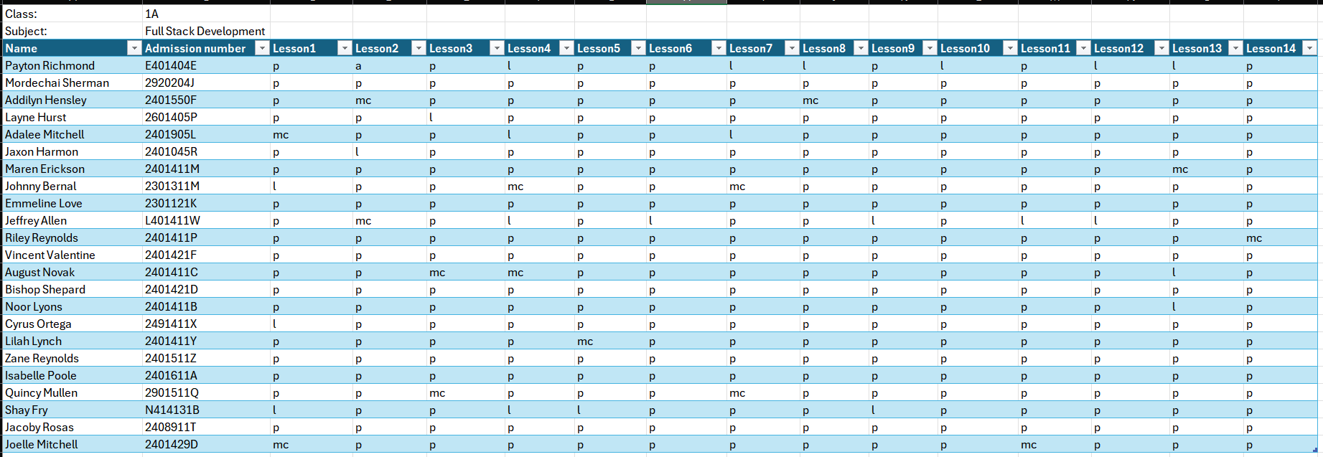
- Populate Lecturer_Class_Mapping class, subject and Lecturer email respectively.
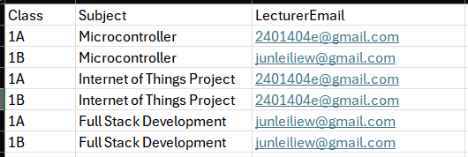
- Set your own email in the gmail activity for both the mainlogic.xaml and the Send_SummaryEmails_ToLecturers.xaml.
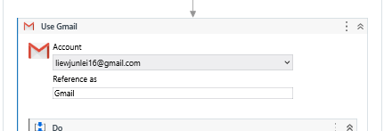
- Open FlowChartMain in UiPath Studio.
- Click Run File in the design tab at the top right.
- Monitor the "Output" panel for real-time logs of students being emailed.
III. Post-Execution
- The robot automatically cleans up temporary files by deleting the .docx copies after the PDF is sent, ensuring the workspace remains uncluttered.
- Check the LecturerReports folder for the summaries sent to staff.

4. Challenges Encountered:

- 1st Challenge: Dynamic Attendance Calculation:

Attendance sheets often have a varying number of lessons. Hard coding a lesson number of 14 would make the Robot miscalculate and flag the wrong students if there was a differing number of lessons.

Solution: We used a dynamic LINQ expression in our calculation activity.
[Math.Round(((CDbl(CurrentRow.ItemArray.Skip(2).Count(Function(x) x.ToString.Trim.ToLower = "p" Or x.ToString.Trim.ToLower = "mc")) / CDbl(Attendance_Dt.Columns.Count - 6)) * 100), 2)]
This counts the "P" and "MC" marks dynamically based on the width of the data table, minus the name, admission number and other fields, ensuring the math is always correct regardless of the semester length.

- 2nd Challenge: Clutter in output folders

Generating a unique Word doc and PDF for every student with low attendance would quickly fill up the hard drive with hundreds of redundant files.

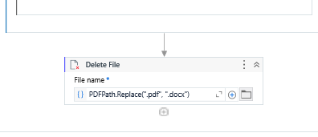

Solution: We implemented automatic cleanup, which means we delete the .docx file at the end of the student loop, immediately after the email was sent to the student, ensuring the project folder is not cluttered with unused files.

- 3rd Challenge: Workflow complexity and modularity

If we included the lecturer summary report workflow in the main logic workflow, it would be a monolithic workflow. The excessive clutter made automation difficult to navigate and debug.

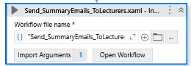

Solution: To ensure a clean and maintainable architecture, the lecturer summary workflow was decouples into a separate workflow, by using the invoke workflow file activity. The robot also smoothly passes the Lecturer Attendance Master Datatable as an in argument to the child process.

Reflection:

Liew Jun Lei (member 1):

Contribution:

- Workflow that sends warning email to students, calculation of attendance

I didn’t realize the planning that actually goes into a simple automation. I learned that you have to think through the whole process before you even touch the software. One of the biggest things I picked up was how to handle complex DataTables—learning how to loop through them, filter out specific students, and merge different tables together without breaking everything was a huge skill for me.
I also learned some cool practical stuff, like using a Word document as a template to create a formal PDF. I had to figure out how to get the robot to find specific words in the doc and swap them out with the student’s actual info. Lastly, I learned how to automate emails so that they don’t just send text, but also include the right PDF attachments and look professional with custom HTML.
Challenges: It definitely wasn't smooth sailing the whole time. I spent a lot of time debugging. I'd run the bot and it would crash just because I had a tiny variable name mismatch or a typo somewhere. It was pretty frustrating at first, but it taught me to be way more careful with how I name things.
Another big thing is the LINQ queries in uipath, I had to google a lot of that stuff and even ask AI how to approach the queries because I wasn’t taught LINQ queries in the assign activities.
There was also a lot of trial and error. Sometimes I’d try one way to do something in UiPath, it wouldn't work, and I’d have to start over and try a different activity to get the same result. Another big headache was the incompatibility between Excel and the DataTables. If the rows or columns in the Excel sheet didn't perfectly match what the DataTable expected, the whole thing would fail. I had to learn how to make sure the data was "clean" before the robot tried to move it around.
Conclusion: The project was a bit of a rollercoaster, but it was worth it. I learned that keeping things modular—like putting the lecturer summary in its own separate workflow—makes life so much easier because the main logic doesn't get cluttered. It makes it way easier to read and fix when things go wrong.
Kenneth Lim (member 2):

Contribution:

- Workflow that send report summaries to lecturers, mapping of lecturer email to class and subject combos

Working on the lecturer Summary part was interesting for me. I had to figure out how to take one giant table of data and split it up so each lecturer only sees their own students. I learned how to use some pretty advanced commands to get a "distinct" list of emails and then loop through them one by one.
One of the cool things I learnt was how to make the excel reports look smart. I set up a loop that checks every student’s attendance. If it’s below 75%, the robot automatically highlights that entire row in yellow using the format range activity. This way the lecturer can easily see which student is flagged. I also learned how to use path.combine and string manipulation to name the files automatically based on the lecturer’s email.
Challenges: The biggest headache was definitely the nested loops. I had a loop for the lecturers, then a loop for the classes, and then another loop for excel rows. It was easy to get lost in the logic, so I had to use log messages activities to see what the bot was actually doing.
I also struggled with the "Class|Subject" split. I had to combine them into one string to get a unique list, but then I had to split them back apart using arr(0) and arr(1) so I could filter the data properly. If I messed up one index, the whole report would be blank. Also, I realized that I had to delete the leftover sheet1, so I had to add a specific step at the end to clean that up.

I also spent a long time figuring out how to attach multiple excel files in the email for each class and subject pair, but was unable to. I decided to choose another route by sending just one excel file but including multiple sheets in each excel file for each class subject pair that the lecturer teaches.

Conclusion: Overall, I’m really happy with how it turned out. It was a lot of trial and error with the Filter Data Table activity to make sure the right students went to the right lecturer. This project really showed me how powerful RPA is for organizing data and something that would take humans hours now only takes a few minutes.

